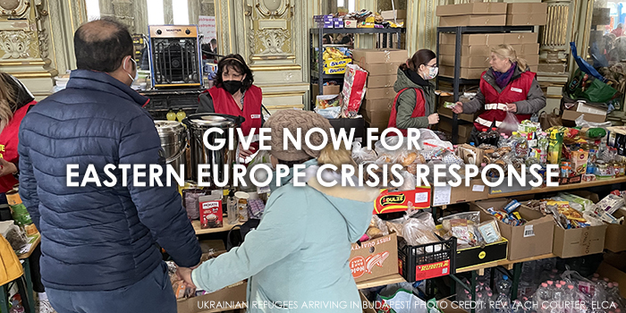

Eastern Europe Crisis Response
The Situation:
On Feb. 24, Russian forces invaded Ukraine, launching land, sea and air attacks. Russia has launched air strikes across the country, including on the capital of Kyiv and other major cities. Airports are now shut, and few railway lines are operational. Millions of civilians fleeing the violence are heading toward Ukraine’s western districts and such neighboring countries as Poland, Moldova, Slovakia, Romania and Hungary. Over 300 civilians have been killed in the conflict so far, and damage to civilian infrastructure has left hundreds of thousands of people without water or electricity. Ukrainian men of military age (18-60) are forbidden to leave the country, so most of those fleeing the violence are women and children. According to one report of the United Nations High Commissioner for Refugees, more than 1 million people are seeking refuge in neighboring countries including Hungary, Poland, Slovakia and Moldova. There are major humanitarian concerns for both internally displaced people and refugees. Many of these Ukrainians fleeing their homes need shelter and such basic necessities as food, water and toiletries. Care for people also includes pastoral and psychological support to address the trauma they’ve endured.
Our Response:
Lutheran Disaster Response is accompanying our companions in Ukraine, Hungary, Poland and Slovakia, as well as such ecumenical partners as Lutheran World Federation and Church World Service, in their humanitarian responses to the crisis. These partners provide refugees with immediate support and supplies such as food, blankets, water and hygiene kits. Presiding Bishop Elizabeth Eaton has joined other religious leaders from Europe and around the globe in issuing an interfaith call for peace in the region.
What you can do:
Pray:
Please pray for those in Ukraine, Russia and neighboring countries that have been affected by the crisis in Ukraine. May God's healing presence give them peace and hope in their time of need.
Give:
Your gifts will be used entirely (100%) to provide support for people impacted by conflict in the region. Write your check to St. Andrews and mark ‘Ukraine’ in the memo line.

